## Creating Workflows with SharePoint Designer 2010

**Lab Time**: 90 minutes

**Lab Folder**: C:\Student\Labs\Workflow

**Lab Overview:** In this lab you will work with the three types of workflows that can be created with SharePoint Designer: List, Reusable and Site. You will get firsthand experience working with the workflow designer and all that it has to offer. In addition, you will see how workflows can be created easily in Visio and brought into SharePoint Designer. Also, you will enhance the user experience of working with the workflow by modifying the form that the user sees when initializing that workflow.

Lab Setup Requirements

* Before you begin this lab, you must run the batch file named **SetupLab.bat**. This batch file creates a new Team Site collection at the location **http://intranet.wingtip.com/sites/Workflow**.

### Exercise 1: Creating a List Workflow

In this exercise you will create a workflow directly on a list. While creating the workflow, you will experience the variety of options available in the workflow designer interface.

1. Start SharePoint Designer 2010: **Start »** **All Programs » SharePoint » Microsoft SharePoint Designer 2010**.
2. Open the site **http://intranet.wingtip.com/sites/workflow** in SharePoint Designer 2010.
3. First create a new group for people to contribute to the site:
   1. In the browser, navigate to **http://intranet.wingtip.com/sites/workflow**.
   2. Using the ribbon select **Site Actions » Site Settings**.
   3. From the **Site Settings** page select **Users and Permissions » People and Groups**.
   4. In the Quick Launch, select **Groups**.
   5. Select the **New** button in the toolbar and use the following information to create a new group and click **OK**:

**Name**: Members

**Group Owner**: WINGTIP\Administrator

**Who can view the membership of the group?** Group Members

**Who can edit the membership of the group?** Group Owner

**Give Group Permissions to this Site**: Contribute

**Note:** If this group already exists, ignore this step.

1. Next, grant the necessary users access to this site:
2. Using the ribbon select **Site Actions » Site Settings**.
3. From the **Site Settings** page select **Users and Permissions » People and Groups**.
4. In the Quick Launch select **Members** under the **Groups** section.
5. Enter the following users into the Select Users field, pressing enter after each name to resolve it and click **OK**:

**Ken**

**Janice**

**Rob**

**Michael**

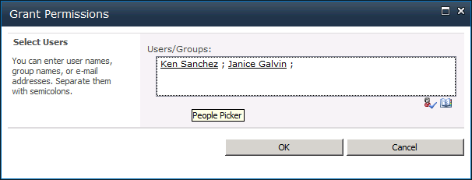

1. Now create a new document library that will be restricted to specific users:
2. Select **Site Actions » New Document Library**.
3. Set the **Name** to **Client Documents**.
4. Click **OK**.

With the list created you now need to modify the permissions.

1. Using the **Quick Launch**, select **Client Documents**.
2. Using the ribbon select **Library Tools » Library » Library Settings**.
3. Under **Permissions and Management**, select **Permissions for this document library**.
4. In the ribbon select **Permission Tools » Edit » Stop Inheriting Permissions** and click **OK** when prompted.
5. Check the **Members** group and select **Permission Tools » Edit » Remove User Permission** and click **OK** when prompted.
6. Click **Workflows** in the **Navigation Pane**. You will start by creating a List Workflow.
7. In the ribbon click **List Workflow** and when prompted, select the **Calendar** list.
8. In the **Create List Workflow** dialog box that appears, type the new name of the Workflow to **Create Event Tasks** and click **OK**.

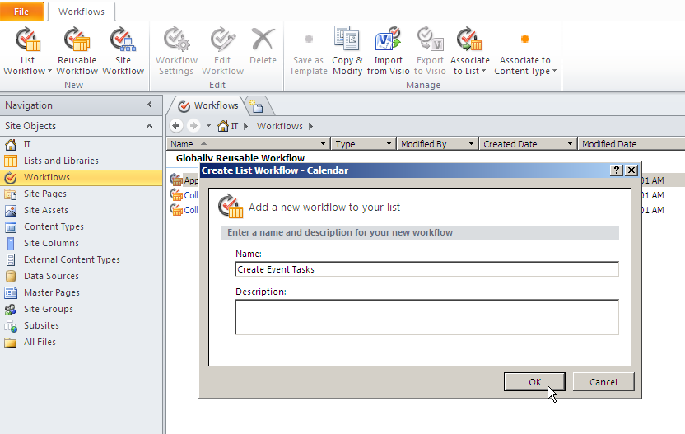

1. The **Workflow Editor** window appears. Click on the text **Step 1**, and then change that to say **Inform site members of the new event**.
2. Click the body of the step. Using the ribbon, select **Action » Send an Email** and then select the link **these users**. In the **Define E-mail Message** dialog box that appears, do the following steps:
3. **To**: Click the **Address book** icon. Click **People/Groups from SharePoint site** and then the **Add** button. In the **Search** text box, type **Members** and then click the **search** icon. Select the resulting value and then click the **Add** button followed by **OK**. Click **OK** in the **Select users** dialog box.
   1. For the **Subject**, click the **ellipses (...)** button. The **String Builder** dialog box will appear. Type **New event in calendar -** and click the **Add or Change Lookup** button which will launch the **Lookup for String** dialog. Use the following information to complete the dialog:

**Data Source**: Current Item

**For the Field from Source**: Title

* 1. Click **OK** to get back to the **Define E-mail Message** dialog box.
  2. For the body of the email, type **The following new event has just been added to the calendar. Please take note.** Double click the word **calendar** and make it **bold**.
  3. On the next line in the body of this email, insert the description of this new event by clicking the **Add or Change Lookup** button at the bottom of the dialog. The **Lookup for String** dialog box that appears, use the following information:

**Data Source**: Current Item

**Field from Source**: Description

**Return field as**: String

* 1. Click the **OK** button in the **Define E-mail Message** dialog box.

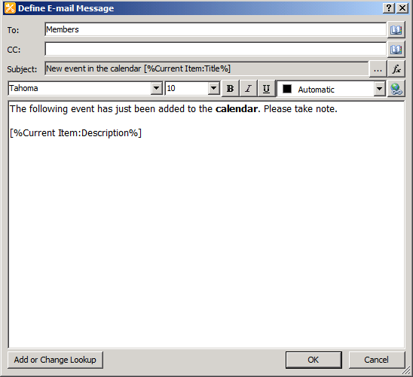

1. Put the cursor below the **E-mail** action that was just created.
2. Start typing **crea**. You notice an IntelliSense-like effect that shows 3 possible results for these letters. Press **[Enter]** on your keyboard to see those 3 actions:

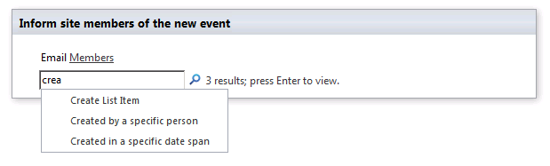

1. Click the first action **Create List Item**.
2. Click the **this list** link.
3. From the **Create New List Item** dialog box that appears, select the list **Announcements**.
4. Select the **Title** field and then click the **Modify** button. From the **Value Assignment** that appears, click the **[fx]** button. In the dialog that appears, use the following information:

**Data Source:** Current Item

**Field from Source:** Title

1. In the **Create New List Item** dialog box, click the **Add** button.
2. For **Set this Field**, select **Body**.
3. For **To**, click the **[fx]** button and from the **Lookup** dialog box:

**Data Source:** Current Item

**Field from Source:** Description

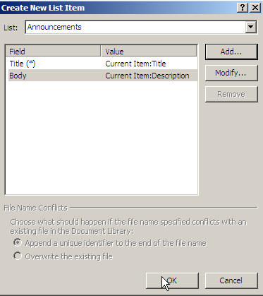

* 1. Click **OK** to complete the **Create New List Item** dialog box.

You will now set to implement both of the actions in parallel.

1. Click immediately above the **E-mail** action.
2. Click the **Parallel Block** button in the ribbon. A parallel block appears. Anything you insert in the Parallel Block will execute in parallel.
3. To move the two actions that are executed earlier, select the first action and click the **Move Up** button in the ribbon.
4. Now select the **Create Item** action and click the **Move Up** button in the ribbon. Both of the actions should now be in the parallel block.

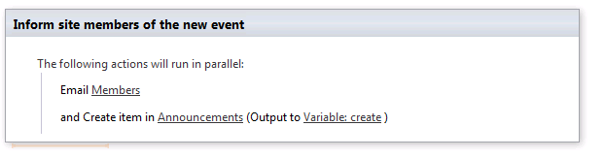

1. Click immediately below the step and then click the **Step** button in the ribbon. Step 2 should appear.
2. Click the **Step 2** and change the name to **Assign Tasks**.
3. Create a conditional statement within the body of the step Assign Tasks. Click the **Condition button** in the ribbon and select **If current item field equals value** condition.
4. Click the **Field** link, select the **Category** option.
5. Click the **Value** link and select **Birthday**.
6. Click inside the **If** conditional branch, and from the ribbon select **Action » Assign a To-do Item** action under the **Task Actions** category.
7. Click on **a to-do item** link to open the **Custom Task Wizard**. Click **Next**. Use the following to complete the dialog:

**Task Title**: Get Cake

1. Click the **Finish** button.
2. Click the **these users** link. Select **People/Groups** **from the SharePoint site** option and click on **Add** button.
3. In the **Select People and Groups** dialog box that appears, type in **Ken** and click the **search** icon. Select **Ken Sanchez**, click on **Add** button, click on **OK** and then click on **OK** at the **Select Users** dialog box.

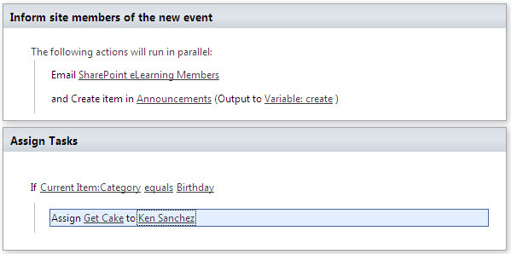

1. Click below the **Assign** action then using the ribbon select **Else-If Branch**. Click **Condition** and select **If current item field equals value** condition.
2. Click the **Field** hyperlink and select **Category**.
3. Click **Value** hyperlink and select **Meeting**.
4. Create **Assign a To-Do Item** within the **Else-If** branch. The task assignment should be **Book meeting room**. The assignment should be made to **Janice**.
5. Click immediately after the **Assign** action. Click the **Condition** button in the ribbon and select the **If current item field equals value** condition.
6. Click the **Field** hyperlink and select **Description**.
7. Click **Equals** and select **contains (ignoring case)** from the list.
8. Click the **Value** hyperlink and enter **food**.
9. Within the **If** conditional branch, create an **Assign a To-Do Item** to **Arrange for refreshments**. Assign this task to **Ken**.

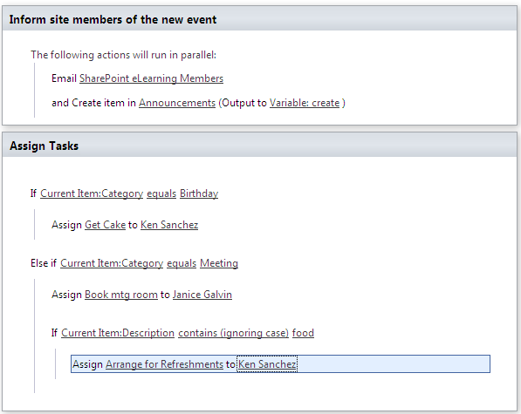

1. You are finished with the workflow but before you save it, you will check it for errors. Click the **Check for Errors** button. You should get a dialog box saying **The workflow contains no errors**. Click the **OK** button to acknowledge that. Click the **Save** button in ribbon’s **Quick Launch**.
2. You want this workflow to start automatically when a new item is created in the Calendar. Click the **Workflow Settings** button in the ribbon. Click the **Start workflow automatically when a new item is created** check box under the **Start Options** section of the Summary Page.

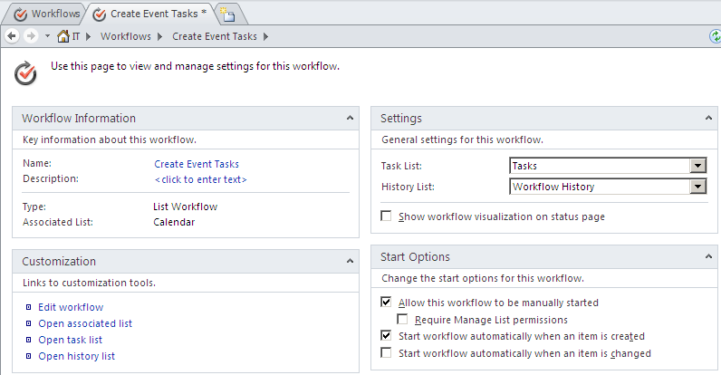

1. Now you are ready to publish this workflow to the Calendar list. Click the **Publish** button in the ribbon. The workflow should now be published to the Calendar list.
2. To test out this workflow, go to the **http://intranet.wingtip.com/sites/workflow** site in the browser, go to the Calendar list, add a new calendar item to today's date using the ribbon: **Calendar Tools » Events » New Event**:

**Title:** Picnic in the park for Mark

**Category:** Birthday.

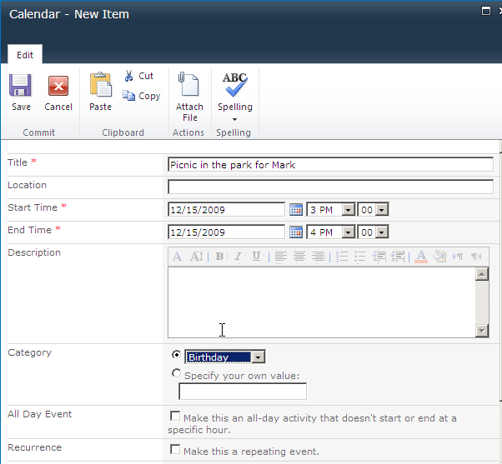

1. From the Quick Launch, click **All Site Content**.
2. Go to the **Announcements** list (**Site Actions » View All Site Content » Announcements**). You should see the new announcement: *Picnic in the park for Mark*.
3. Click the **Tasks** list in the Quick Launch. There should be a new task assigned to **Ken Sanchez** to **Get Cake**.

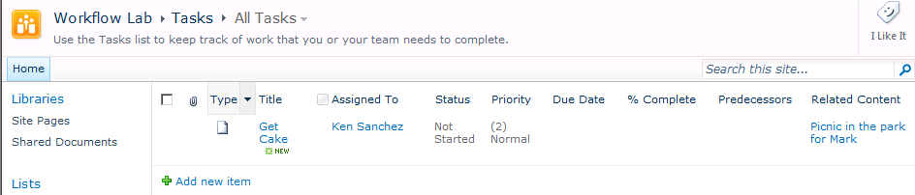

1. Click the **Calendar** list once again.
2. Add a new event for tomorrow.

**Title:** Board Meeting

**Description:** food will be served at the meeting

**Category:** Meeting

1. Click the **Save** button
2. Click the **Tasks** list. You should see a task assigned to **Janice** to **Book a meeting room**.
3. On the top right hand side of the browser, you should see that Administrator is currently signed in. Change the user to be Janice by clicking on the **Administrator** drop down and by selecting the **Sign in as Different User** link.
4. From the Windows Security dialog box that appears, click on **Use another account**. Login as **Janice**.
5. When you are logged in as Janice, click the **Book meeting room** task and from the Workflow dialog box that appears, click the **Complete** **task** button.
6. Now that the Book meeting room task is completed, a new task appears for arranging for refreshments assigned to Ken Sanchez.

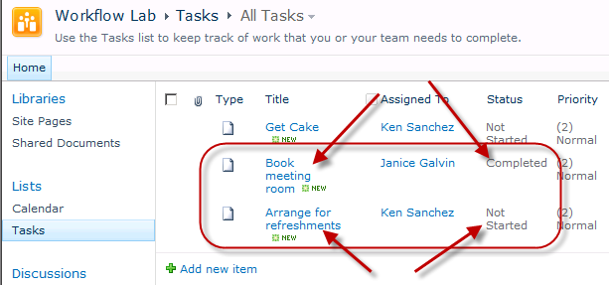

The workflow is working as expected.

1. Log back into the site as **Administrator**.

In this exercise you created a new list workflow using SharePoint Designer and tested its functionality.

### Exercise 2: Building Workflows with Visio 2010 & SharePoint Designer 2010

In this first exercise you will create a simple process in Visio 2010 and export it to SharePoint Designer 2010.

1. Launch **Visio 2010** and select the **FlowChart** folder.

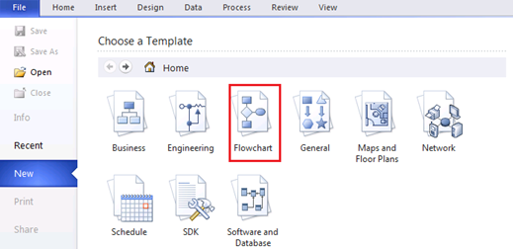

1. Within the **FlowChart** folder create a new file using the **Microsoft SharePoint Workflow** template.

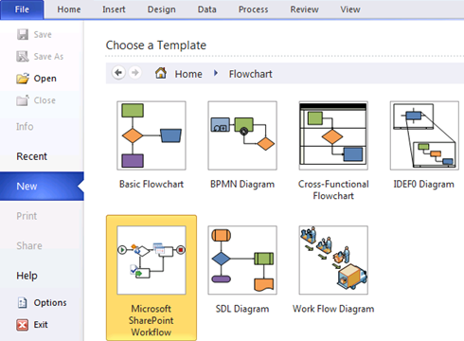

1. Click the **Create** button in the right pane.
2. Using the toolbox on the left hand side of the window, locate the **SharePoint Workflow Terminators** section and add a **Start** and **Terminate** shape to the diagram.

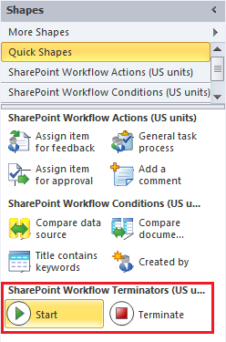

1. Open the **SharePoint Workflow Conditions** section and add a **Compare Data Source** shape to the diagram.
2. Double click and change its name to **Check if manager approval is needed**.
3. Open the **SharePoint Workflow Actions** section and add three **Log to History List** shapes to the diagram.
4. Double click the first and change its name to **Log Manager approval required**.
   1. Double click the next and change its name to **Log automatically approved**.
   2. Double click the last and change its name to **Log submission to HR**.
5. Add the process flow connections between the shapes. Use the image below as an example.
6. Add connections by hovering over the source shape, clicking and dragging one of the arrows to the target shape.

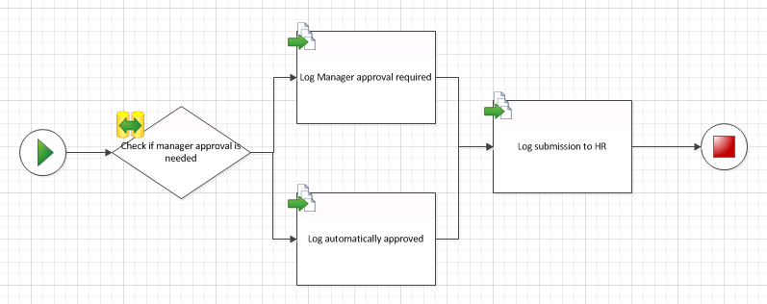

1. Label the connections flowing from the condition yes or no depending on the process flow.
2. Right click the connection from **Check if manager approval is needed** to **Log Manager approval required** and select **Yes**.
3. Right click the connection from **Check if manager approval is needed** to **Log automatically approved** and select **No**.

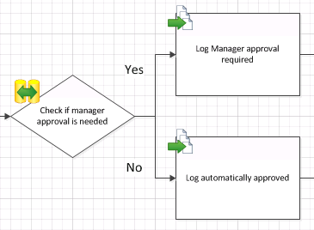

1. Save the process diagram to [[LAB FILES]]\Solution with a name of TimeSheet Submission Workflow.vsd.
2. Export the process by selecting the **Process** ribbon in Visio 2010 and clicking the **Export** button.

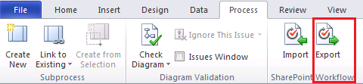

1. Save the exported workflow to [[LAB FILES]]\Solution with a name of TimeSheet Submission Workflow.vwi.
2. Launch Microsoft Office **SharePoint Designer 2010** and open the lab site at **http://intranet.wingtip.com/sites/Workflow** using the Open Site button on the main page.
3. Click the **Workflows** item on the **Navigation** links on the left hand side of the window to display the current Workflows.

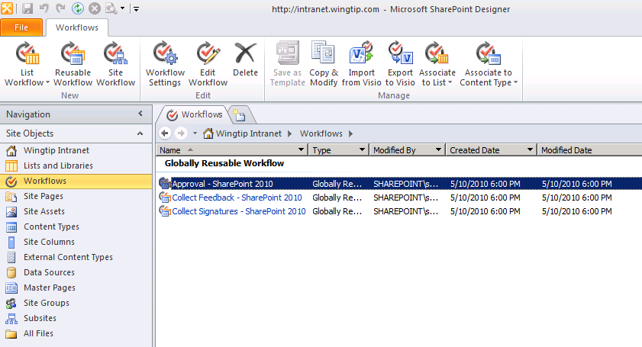

1. Click the **Import from Visio** button in the ribbon and select the *.vwi file at [[LAB FILES]]\Solution\TimeSheet Submission Workflow.vwi then click **Next**.
2. Verify the **Name** is **Timesheet Submission Workflow**.
3. Choose the **Reusable Workflow** option and select the **Time Sheet** content type.

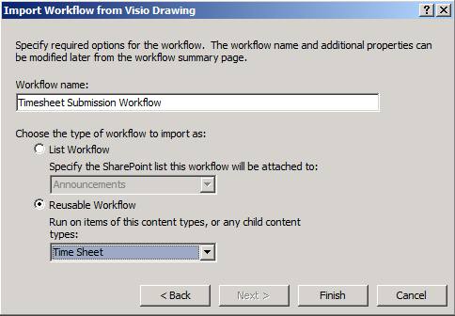

**Note:** If you don’t have **Time Sheet** as an option in the **Reusable Workflow** selector, you likely did not run the lab setup file or there was an error. Do not select the **Time Card** content type.

* 1. Click **Finish** to import the workflow. This can take a while.

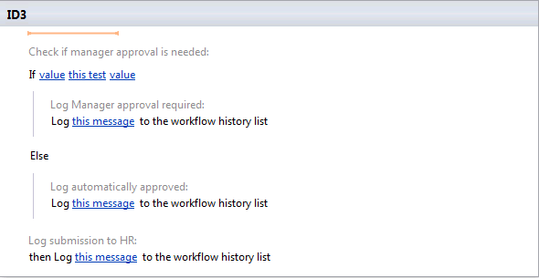

1. Add two new local variables to store the maximum hours before approval is required and the employee name and set it. For now we’ll store the employee id instead of the name. We’ll look up the employee name in a later exercise.
2. Click the **Local Variables** button in the **Workflow** ribbon.
3. In the dialog, click the **Add** button and create a new variable with a name of **EmployeeName**.
4. Set the **Type** to **String**.
5. Click **OK** on all dialogs to create the variable.
6. Repeat the above steps to create a variable named **MaxHours** of type **Integer**.
7. Store the **EmployeeID** as the employee’s name. This will be replaced later with the employee’s real name requested from the HR system.
8. Place the selector at the top of the main step.
9. Click the **Action** button in the **Workflow** ribbon and select **Set Workflow Variable**.

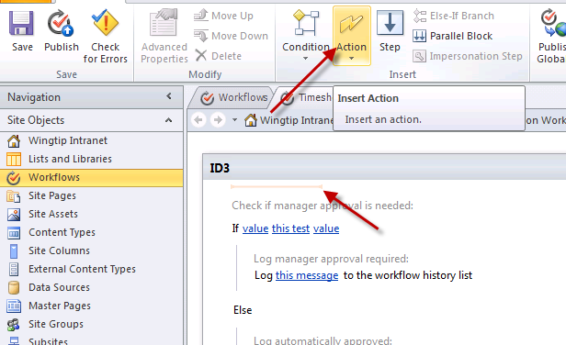

1. Click the **workflow variable** link and select **Variable: EmployeeName**.
2. Click the **value** link and then click the **fx** button.
3. In the dialog select **EmployeeID** in the **Field from source** drop down list.

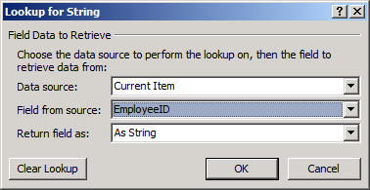

* 1. Click **OK** to close the dialog.

1. Store **40** in the **MaxHours** variable.
2. Place the selector just below the action you just added, right before the first **If** statement.
3. Click the **Action** button in the Workflow ribbon and select **Set Workflow Variable**.
4. Click the workflow variable link and select **Variable: MaxHours**.
5. Click the value link type in **40**.
6. Define a condition that will be true if the number of hours worked is greater than **MaxHours**.
7. Click the first **value** link in the **If** statement then click the **fx** button to assign a value.
8. Leave **Data Source** as **Current Item** and select **Hours** in the **Field from source** drop down list. Click **OK** when you are done.
9. Click this test and select **is greater than**.
10. Click the second **value** link in the **If** statement then click the **fx** button to assign a value.
11. Set **Data Source** to **Workflow Variables and Parameters**.
12. Set **Field** from source to **Variable: MaxHours**.
13. Click **OK** to close the dialog.
14. Define the message logged when a timesheet requires manager approval. You’ll be performing a lookup in the Employees list to find the name of the employee later.
15. Click the **this message** link on the first **Log** action that immediately follows the **If** condition.
16. Click the **…** button to define the text of the logged message.
17. Enter the text **The time sheet for**.
18. Click **Add or Change Lookup** to retrieve information from the environment.
19. Select **Workflow Variables and Parameters** in the **Data Source** drop down list.
20. Select **Variable: EmployeeName** in the **Field from source** drop down list.
21. Click **OK** to close the dialog.
22. Finish the message by entering **requires manager approval**.
23. Click **OK** to close the dialog.

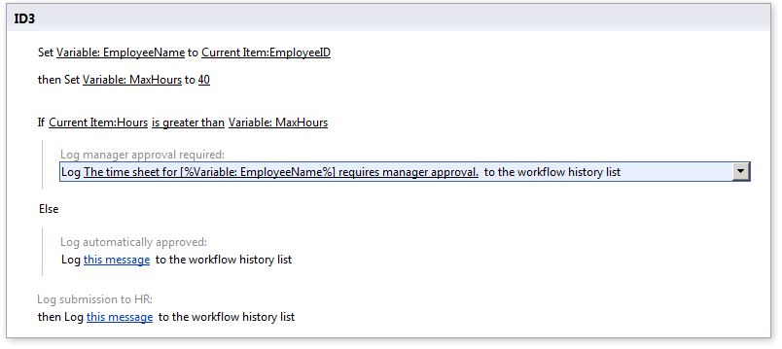

1. Repeat the previous step for the second **Log** action with the following exceptions
2. When finishing the message instead of entering requires manager approval, enter does not require manager approval.
3. Log that the time sheet has been approved and submitted to HR. It hasn’t actually been submitted at this point, that will happen in a later exercise.
4. Click the **this message** link on the final **Log** actions.
5. Click the **[…]** button and enter the message **The time sheet has been submitted to HR**.
6. Click **OK** to close the dialog.
7. Finish the workflow’s final settings and publish it to the SharePoint site.
8. Click the first **Timesheet Submission Workflow** item on the workflow header to return to the workflow’s home page.



1. Check the **Show workflow visualization** on status page check box (found in the **Settings** group).

If the **Show workflow visualization** option is either disabled or does not appear, ensure the following features are activated: **Visio Web Services** (at the **farm** level… do this from within Central Administration), **SharePoint Server Enterprise Features** (at the **site collection** level) and **SharePoint Server Enterprise Features** (at the **site** level).

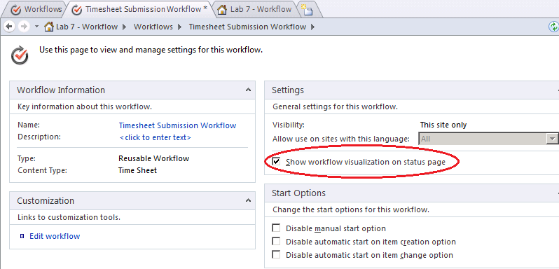

* 1. Click the **Save** button to save the workflow settings.
  2. Click the **Publish** button in the **ribbon** to publish the workflow to the SharePoint site.

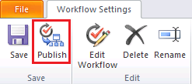

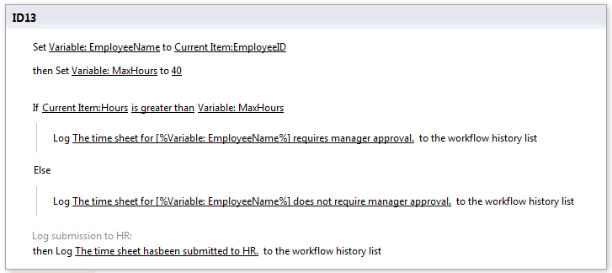

* 1. Click the **Associate to Content Type** button in the ribbon and select **Time Sheet**.

If the list of content types is blank when clicking this button, you may need to **Save** the workflow, and then click the **Content Types** section in the left-hand **Navigation** section of **SharePoint Designer 2010** to refresh the content types. Then you can go back to the workflow you created and repeat this step.

* 1. When the browser window loads, scroll to the bottom and click **OK**.

1. Return to the Internet Explorer page pointing to **http://intranet.wingtip.com/sites/Workflow**.
2. Click the link in the quick launch bar for **Time Sheets**.
3. Switch to the **Documents** ribbon and click **New Document** to create a new document.
4. Save the new document to the **Time Sheets** document library.
5. When saving the document, set the **EmployeeID** to **1**.
6. Set the **Hours** to **38**.
7. In the document library select the new document’s drop down menu and click **Workflows**.
8. Click **Timesheet Submission Workflow** to start the new workflow.
9. On the **Initiation** page click **Start** to start the workflow.
10. When the workflow has started, navigate back to the **Time Sheets** list and click the **Completed** link on the item.
11. View the **Workflow Information** page and see that the steps in the workflow were completed.
12. Repeat the process if you’d like using a Time Sheet that has hours that are greater than 40. Keep in mind that you’ll now have to approve the task that is created.

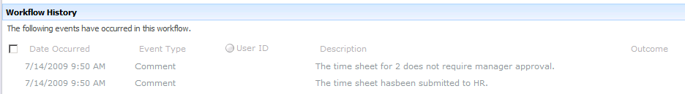

1. Since the process was changed by your work in SharePoint Designer, export those changes back to Visio to keep the process models in sync.
2. Switch back to **SharePoint Designer** and verify the workflow is still in the active window.
3. Click the **Export to Visio** button in the ribbon.
4. Save the updated *.vwi file as Timesheet Submission Workflow.vwi inside the lab folder.
5. Switch back to **Visio** and import the update .vwi file.
6. Click the **Import** button in the **Process** ribbon tab.
7. Select the Submission Workflow.vwi file from your student folder.
8. The Visio diagram should now be updated to include the **Set Workflow Variable** tasks added in **SharePoint Designer**.

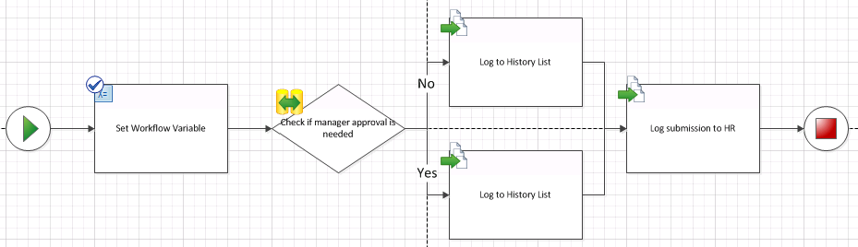

In this exercise you imported a workflow created in Visio 2010 into SharePoint Designer, made a few changes and then deployed it to SharePoint. You then sync’d those changes with the original Visio diagram.

### Exercise 3: Creating a Site Workflow

In this exercise you will create a site workflow which will be used to add entries to the Announcements list. You will enhance the user experience by modifying the workflow's initiation form using Microsoft InfoPath 2010.

1. Launch **SharePoint Designer 2010** load **http://intranet.wingtip.com/sites/workflow**.
2. Click **Workflows** in the Navigation Pane.
3. Click the **Site Workflow** button in the ribbon.
4. Enter **Site Announcement** as the name of the **Site Workflow** and click the **OK** button.

You will now create some site initiation form parameters that request information from the user when the workflow is started.

1. Click the **Initiation Form Parameters** button in the ribbon. The **Association and Initiation Form Parameters** dialog box will appear.
2. Click the **Add** button. The **Add Field** dialog box appears.
3. Set **Field Name** to **Announcement Message**.
4. Choose **Single line of Text** for information type in the **Information Type** drop down list.
   1. Click **Next** button and then click on **Finish**.
   2. Click the **OK** button in the **Association and Initiation Form Parameters** dialog box to complete the dialog.
5. In the workflow designer, insert the action **Create List Item**.
6. Click the **this list** hyperlink and pick the list **Announcements**.
7. Click the **Title(*)** field and then click the **Modify** button.
8. For the **Set this field**, pick **Title**.
9. For **To this value**, click **[fx]** and use the following information to add the workflow form field:

**Data Source:** Workflow Variables and Parameters

**Field from Source:** Parameter: Announcement Message

**Return field as:** As String

1. Click **OK**.
2. Click the **OK** button to accept the configuration of the **Create New List Item** dialog box.

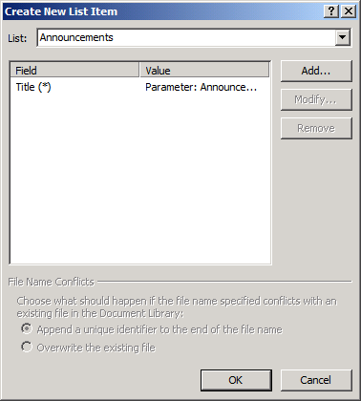

1. You are now ready to publish this workflow. Click the **Publish** button in the ribbon.
2. Once the workflow is published, go to the browser and navigate to the **http://intranet.wingtip.com/sites/workflow** site.
3. Login as **Janice**.
4. Click **Site Actions » View All Site Content** and then select **Site Workflows**
5. Click the **Site Announcement** workflow. You should see a form asking for the **Announcement Message**.

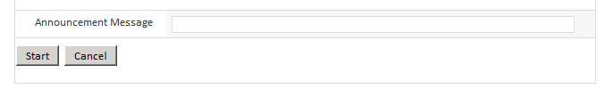

1. Once the workflow is done, click the **Home** link to go to the home page of the **http://intranet.wingtip.com/sites/workflow** site.
2. If you navigate back to the site’s Announcements list (**Site Actions » View All Site Content » Announcements**) you will see the announcement you created.
3. Go back to **SharePoint Designer 2010**.
4. While looking at the workflow that you just created, click the **Workflow Settings** button in the ribbon.
5. Click the **Site Announcement.xsn** file under the **Forms** section of the Summary Page for **Site Announcement**. Microsoft InfoPath 2010 should open showing you the form that can now be customized.
6. Click the **Start** button. In the ribbon select **Control Tools** **»** **Properties**. Change the **label** from **Start** to **Add Announcement**.
7. You are now ready to publish this form back to the workflow. Click the **File** tab and then click the **Quick Publish** button.

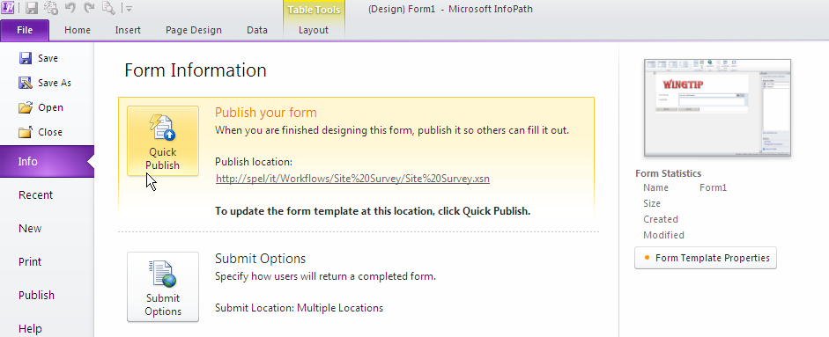

1. A dialog box should come up asking you to save this file.
   1. Click **OK**.
   2. Save this form as **Site Announcement.xsn** in **[[LAB FILES]]** folder. It should inform you that your form template was published successfully. Click the **OK** button.
2. Go to the browser and sign in as **Ken**.
3. Using the ribbon select **Site Actions » View All Site Content » Site Workflows**.
4. Click the **Site Announcement** workflow. You should now see the new form that you have just created using InfoPath 2010.

In this exercise you created a new site workflow and modified the generated form with InfoPath 2010.